EPIC Automations Web Site Doc Content

**# CT-RX002-26**

Created by:

Purushothaman K

|  |  |  |  |  |
| --- | --- | --- | --- | --- |
| **Home** | **Our services** | **Costumer & about Us** | **Carrer & training** | **Contact us** |

**Fifth page**

Flex Picker

**Fourth page**

Line Automations Like in OLA

**Third page**

SPM Machine

**Second page**

Video Should Robotic & automations

**First page**

Company name

**Home Page: Slider Page**

PLC & HMI Programming Services

Robot Programming Services

Custom panel design   
& manufacturing

SCADA

Special Purpose Machine (SPM)

Robotics & Automations

* **Robotic & Automations, (“Use any three for the UI”)**

Machine tending, in manufacturing, refers to the automated process of loading and unloading parts into and out of production machines, often using robots. This can involve various machines like CNC machines, injection molding machines, and more. The goal is to automate repetitive tasks, improve efficiency, and reduce the need for human operators in potentially hazardous or monotonous environments.

Learn More “From Logic to Touch – Total Control.  
We Program the Brains and the Face of Automation.”

L

**MACHINE TENDING**

“Automate the Load, Elevate the Output.”

Material handling refers to the movement, protection, storage, and control of materials and products throughout the manufacturinMaterial handling refers to the movement, protection, storage, and control of materials and products throughout the manufacturing, warehousing, distribution, consumption, and disposal stages.

It plays a critical role in improving efficiency, reducing costs, and ensuring safe working environments in industrial and commercial operations.g, warehousing, distribution, consumption, and disposal stages.

It plays a critical role in improving efficiency, reducing costs, and ensuring safe working environments in industrial and commercial operations.

Deburring is the process of removing small imperfections, known as burrs, from the surface edges of metal, plastic, or other materials after machining, drilling, milling, cutting, or stamping operations. These burrs are unwanted projections that can affect the fit, function, safety, and aesthetic quality of the finished part.

Automated palletizing equipment increases productivity & reduces worker injury & fatigue in warehouse, distribution, and manufacturing environments.

Learn More “From Logic to Touch – Total Control.  
We Program the Brains and the Face of Automation.”

L

Learn More “From Logic to Touch – Total Control.  
We Program the Brains and the Face of Automation.”

L

Learn More “From Logic to Touch – Total Control.  
We Program the Brains and the Face of Automation.”

L

**Material Handling**

“Streamline the Move.   
Strengthen the Process.”

**Palletizing**

“Automated Palletizing. Unlimited Productivity.”

**Deburring**

“Precision Finishing for Peak Performance.”

* **Special Purpose machine**

CNC (Computer Numerical Control) automation revolutionizes modern manufacturing by enabling high-precision, repeatable, and efficient production processes. Widely used across industries such as automotive, aerospace, electronics, and metal fabrication, CNC systems automate the control of machine tools like lathes, mills, routers, and grinders.

By integrating software-driven commands with mechanical operations, CNC automation minimizes human error, increases production speed, and ensures consistent quality. From prototyping to mass production, CNC technology plays a vital role in optimizing workflows, reducing downtime, and meeting the demands of complex and customized manufacturing.

Learn More “From Logic to Touch – Total Control.  
We Program the Brains and the Face of Automation.”

L

**CNC Automations**

“Consistent. Reliable. CNC Done Right.  
Automation That Never Misses a Cut.”Unlimited Productivity.”

Packing Machine Automation: Accelerating End-of-Line Efficiency

Packing machine automation refers to the use of automated machinery and intelligent systems to pack, seal, label, and prepare products for distribution without human intervention. It's a key component in modern manufacturing and logistics, designed to improve speed, consistency, and cost-effectiveness in the end-of-line process.

**Packaging machine**

““Consistent Packing, Every Single Time.  
Efficiency Engineered into Every Machine.

Learn More “From Logic to Touch – Total Control.  
We Program the Brains and the Face of Automation.”

L

* **Control panel design & manufacture,**

Control Panel Design & Manufacturing

At the core of every automation system lies a reliable and intelligently designed control panel. We specialize in the custom design, engineering, and manufacturing of high-performance electrical control panels that meet international safety and operational standards.

From small relay-based enclosures to large PLC/SCADA-integrated panels, we deliver solutions that are engineered for performance, scalability, and longevity.

**Control panel design & Manufacture**

“Precision in Design, Power in Control.  
Panels Built to Perform, Engineered to Last.”

Learn More “From Logic to Touch – Total Control.  
We Program the Brains and the Face of Automation.”

L

* **Robot Programming,**

**Robot Programming**

“Turning Code into Capability.  
Robots That Work the Way You Want.”

Robot Programming: The Brain Behind Automation

Robot programming is the process of creating instructions that guide industrial or collaborative robots to perform specific tasks—such as welding, assembly, pick-and-place, palletizing, inspection, and more.

It is the core of robotic automation, enabling machines to operate autonomously, adapt to new processes, and perform with precision and repeatability.

* **PLC and HMI Programming,**

PLC and HMI programming are essential components of industrial automation, working together to control and monitor processes. PLCs (Programmable Logic Controllers) execute logic and control functions based on input signals, while HMIs (Human Machine Interfaces) provide a visual interface for operators to interact with and monitor the PLC and the system it controls.

**PLC and HMI Programming**

“From Logic to Touch – Total Control.  
We Program the Brains and the Face of Automation.”

|  |  |  |  |  |
| --- | --- | --- | --- | --- |
| **Home** | **Our services** | **Costumer & about Us** | **Carrer & training** | **Contact us** |

**About US Page:**

1. **Palletizing robots**

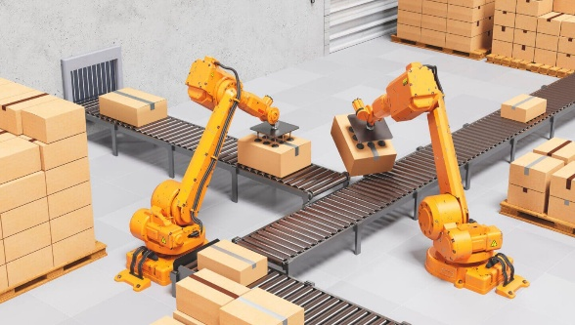**Palletizing robots automate the task of stacking products onto pallets with high speed, accuracy, and consistency.**

**Integration with top automation platforms like Siemens and ABB ensures reliable, scalable, and smart palletizing**

**solutions.**

1. **Line Automation programming:**

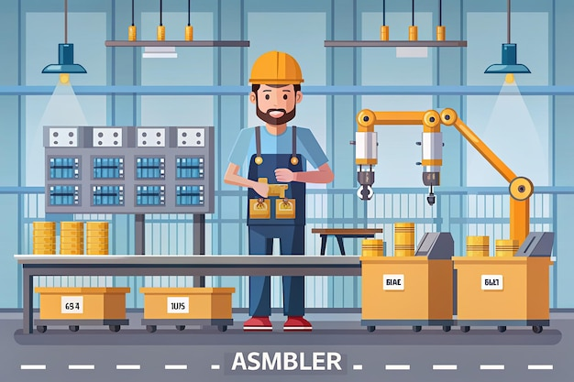

**Line automation programming involves using PLCs (Programmable Logic Controllers) to control and monitor machinery in a production line. SCADA (Supervisory Control and Data Acquisition) systems are integrated to visualize real-time data, manage alarms, and ensure smooth operations across the entire process. Together, PLCs handle the actual control logic, while SCADA provides an interactive interface for operators to monitor, control, and optimize the automation line efficiently.**

1. **Machine Tending**

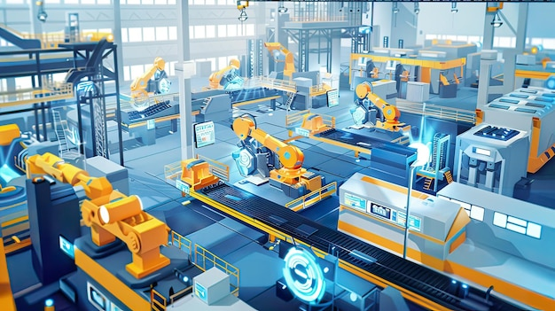**Machine tending using robots involves the automated loading and unloading of parts into machines such as CNCs, injection molding machines, or presses. Robotic systems improve productivity, reduce human error, and enhance workplace safety by performing repetitive tasks with high precision and consistency. These systems can be integrated with vision systems and sensors for smarter, more flexible operations.**